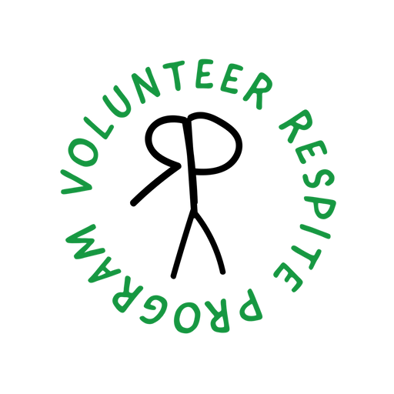**Over the last several years we’ve had an increase in the number of people interested in learning more about volunteering with people with dementia and other illnesses.**

**One of the greatest unmet needs of the families we serve is opportunities for family care givers to get a break from caregiving. We are happy to announce that we have created a four-session training course for those volunteers who would like to be able to provide support to family caregivers. During this training you will gain information and increase your skills and comfort level in spending time with someone who has dementia and other illnesses.**

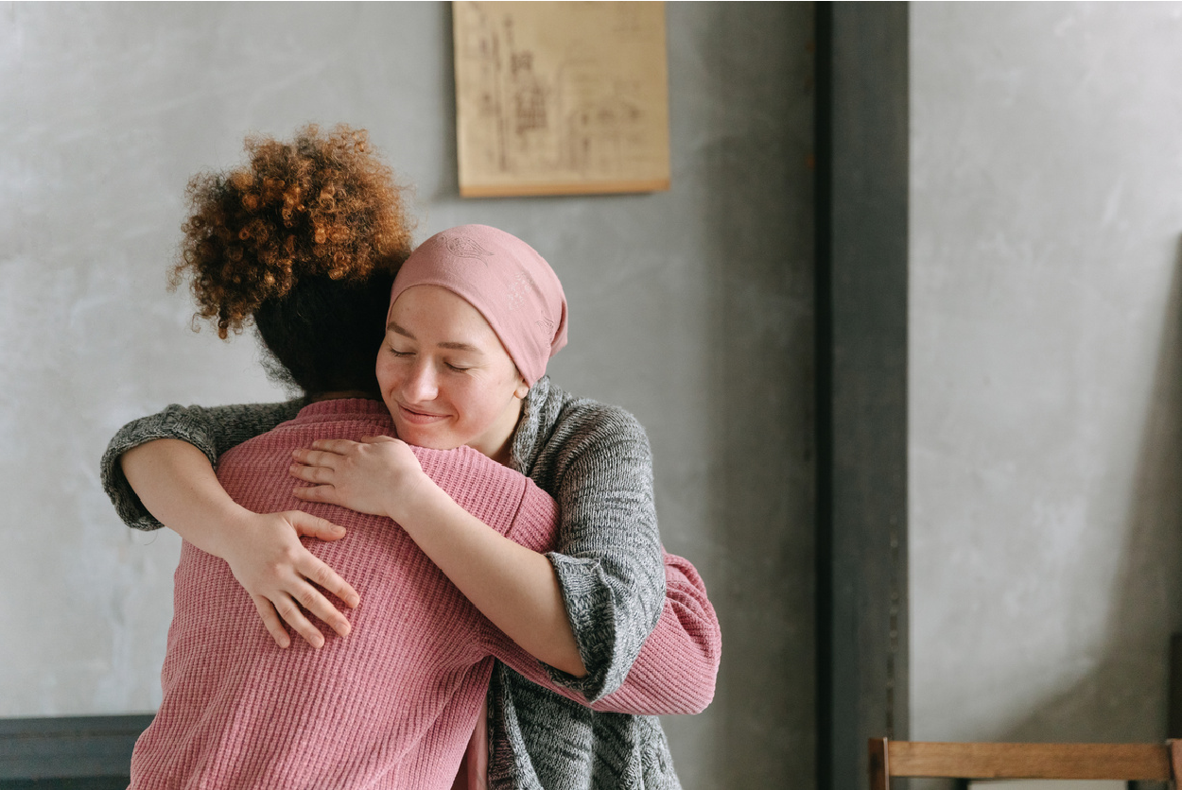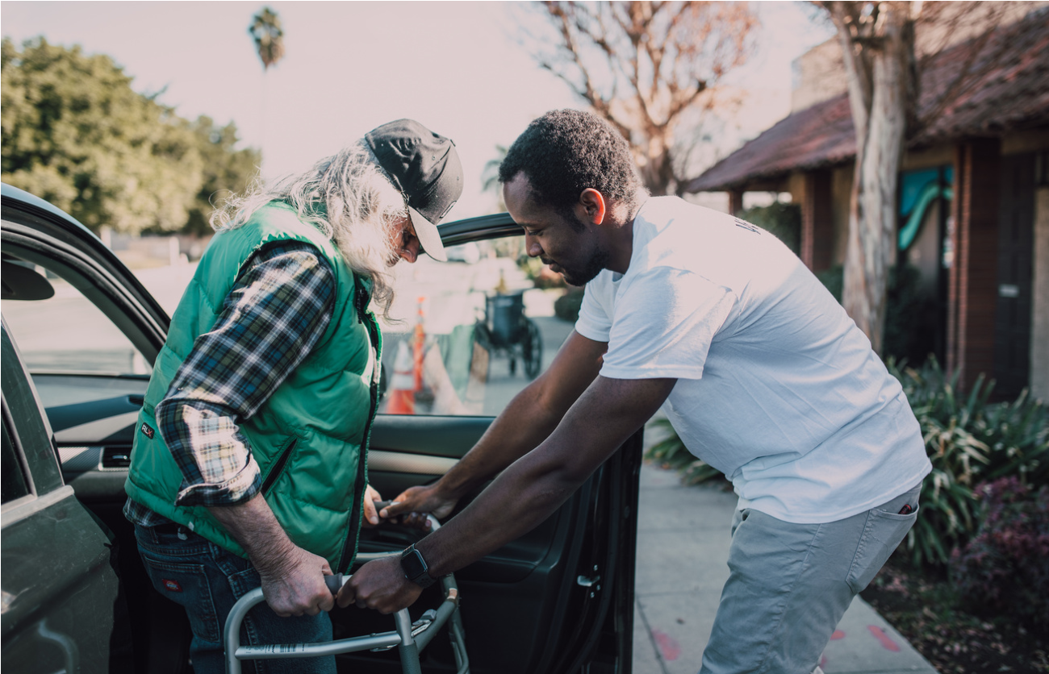

**The classes will be held 2 consecutive Fridays on the following dates:**

**When: May 24th and 31st**

**Time: 12:00pm-2:30pm**

**Location: Active Aging Wellness Center 200 N. 4th street Platte City (Lion’s Club)**

**Course topics will include Introduction to Caregiver Support, Dementia, Communication, Body Mechanics and Caregiving Skills, Family as Unit of Care, Grief and Bereavement and Boundaries.**

**\*Class size is limited to the first 15 volunteers who respond with interest. Registration is open until May 22, 2024.**

To register: https://vrpmissouri.wixsite.com/volunteer-respite-pr

Call 254-206-1737 or Email avyogaandwellness@gmail.com