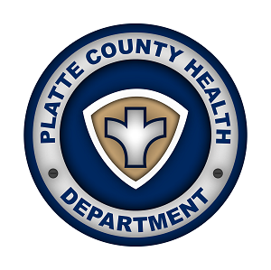

FOR IMMEDIATE RELEASE: Tuesday, April 21, 2020

Media Contact:
Natalie Klaus – Public Information Officer
Platte County Health Department
(816) 858-2412
natalie.klaus@plattehealth.com

PLATTE COUNTY HEALTH DEPARTMENT’S COVID19 SYMPTOM SELF-REPORTING TOOL GOES LIVE

Platte City, MO -- (April, 21st 2020) Platte County Health Department (PCHD) will now offer a Self-Reporting Tool for COVID19 symptoms. The short questionnaire aims to:

- Determine how many of our residents have COVID19 symptoms, so we can better understand its effect on our community.

- Identify persons who may meet the criteria for testing.

Not everyone who fills out the survey will be tested. At this time, testing is free. The survey is now available on the Platte County Health Department’s website. Survey Link: https://www.plattecountyhealthdept.com/newsview.aspx?nid=10432

If a Platte County Resident believes they have symptoms and would like to be tested for COVID19, they must first fill out the Symptom Self-Reporting Tool, and will then be evaluated to determine if they qualify for testing. Once their information has been submitted, they will be contacted by a nurse and possibly brought in for testing.

“To get the best possible picture of the number of cases in our county, we ask that you please fill out the survey accurately and completely. The overarching goal of this public health response is to minimize the adverse health impacts of exposure to COVID-19 in Platte County.” – Mary Jo Vernon, Director of PCHD.

If the public has questions about the survey they call the Platte County Health Department at 816-858-2412 Monday – Friday 8am – 4:30pm or visit our website www.plattecountyhealthdept.com

###
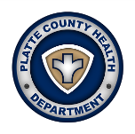
1201 East Street
Parkville, MO 64152
816.587.5998

212 Marshall Road
Platte City, MO 64079
816.858.2412

